Adaptive glass system: idea development and design
S Bizonova¹
¹ Institute of Architectural Engineering, Faculty of Civil Engineering, Technical University of Kosice, Vysokoskolska 4, 040 23 Kosice, Slovakia

E-mail: silvia.bizonova@tuke.sk

Abstract. The aim of the paper is to create a concept of a glass system independently reacting to the parameters of the environment in which is located. Autonomous insulation unit is responded to changes of environmental parameters, capable of evaluating mode efficiency with and without the use of selective layers. Parameter specification of individual modes, description of operation is needed. As a result, a construction scheme of the glass system is proposed.
- Introduction – State of Art
Adaptive architecture, bearing the idea of adapting to the environment in which it is located, is the logical result of the efforts to continuously reduce energy consumption and, at the same time, a new tool to maximize the use of structures in relation to energy. Adaptability is the ability to change the state / shape / properties of a structure as the environmental conditions have changed at a given time. It can be basic adaptability, where the structure reacts by changing the effect of weather conditions only on the basis of the influence of physical forces (pressure, tension, other stress). Thus the shape changes are based on its material characteristics (tensile strength, compression, elastic modulus). Advanced adaptability is manifested by a change based on a pulse from a device that specifically evaluates current environmental conditions. The device recognizes different scenarios and adapts the structure according to the formula given to it. A passive adaptation is a prerequisite for a flexible / formable material, while in advanced adaptation, the material of the structure can be rigid and only the structure layout itself allows changes. In connection with window structures, basic adaptive constructions include thermochromic glazing. Advanced adaptive systems include electrochromic glass [1], suspended particle device, liquid crystal and others. These currently belong to the glazing with the highest adaptability [2]. By applying voltage, the glass changes its colour and optical-energetic properties. The proposed glass system belongs into the category of advanced adaptive. Its parameters are assessed by numerical analysis.
- Window that knows what to do
When choosing a suitable glass system, the first of all is its future location. It is both orientation to the cardinal points and the climate zone (see table 1). A properly selected glass system can thus mitigate the effects of weather extremes on indoor thermal comfort for a given site and the energy requirement to achieve it again. The glass system always has the lowest heat transfer coefficient while respecting the other optical-energy properties. In such highly insulated glass systems, where the heat transfer coefficient values are close to those of the peripheral wall, the heat flux between the exterior and the interior is logically very low. This could be a disadvantage if there was a situation where the heat flux would be required. Ideally, in a hot climate, the glass system that reflects all the infrared radiation (from the sun and surrounding surfaces) as well as all UV radiation is suitable. At the same time, it is able to transmit all infrared radiation from the interior to the exterior and at the same time maintain the transparency and allow the visible component of light to penetrate. In cold climates, it would be able to transmit to the interior radiation of all wavelengths except UV while reflecting all infrared radiation back to the interior.
Table 1. Required parameters of the glass system for a specific climate [3].
Climate | τ_{V} | g | U [W/(m².K)]
Cool climate (prevailing heating loads) | >0.70 | >0.60 | <2
Temperate climate (prevailing heating loads) | >0.70 | >0.50 | <2.5
Hot climate (prevailing cooling loads) | >0.60 | <0.40 | <4
The design of the adaptive glass system must be approached conceptually. In the case of a glass system as a specific structure, it is necessary to consider the properties of the structure in individual modes, as it is only mechanical changes (removal of selected parts), not a change in properties of the same structurally unchanged structure. Window films play an important role in the concept. The state they create by their presence/absence defines the thermal-optical parameters of the glass system mode. Window film substitutes the glass pane and its thermal conductivity and emissivity parameters are comparable to conventional clear glass pane. Its advantage over conventional glass is a thickness of less than 1mm and a negligible weight that limits using or increases the cost of multiple glass systems.
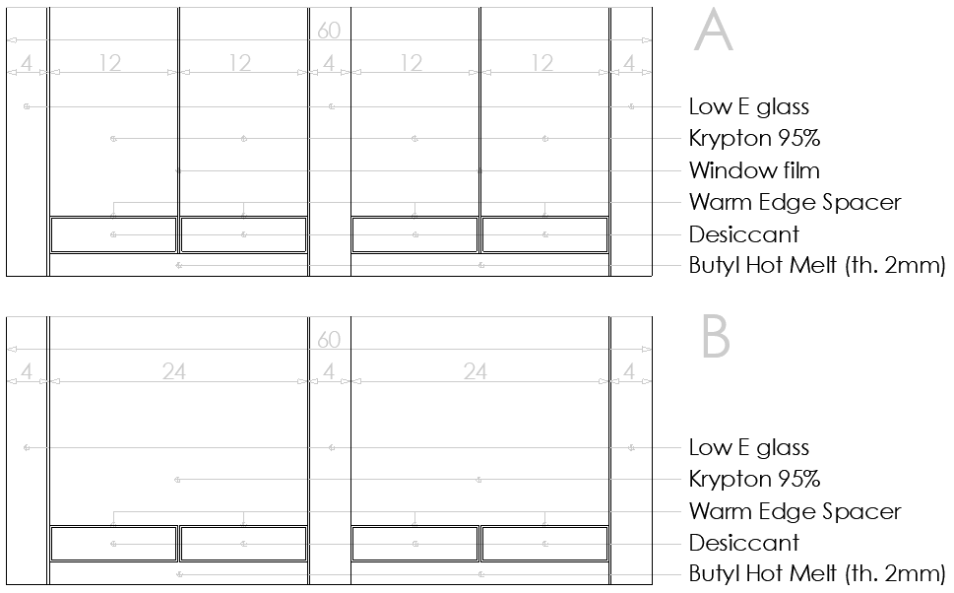
Figure 1. Investigated glass systems.
The glass system consists of three glasses with a low-emissivity layer at positions 2, 3 and 5. Window films without low-emissivity coatings are placed separately in the space between the glasses. The thickness of the gas gaps in the presence of films is 12mm (figure 1A), they are four. In the absence of films state, the gap thicknesses merge to form two 24 millimetre gaps (see table 2, figure 1B). It follows from the theory of heat transfer in closed air gaps that as the thickness of the gas gap increases, the proportion of the convection to the conduction increases (see figure 1). It can therefore be assumed that at a gap-filled thickness of more than 12 mm, the heat transfer is almost exclusively by convection and this ratio does not change significantly with the further increasing thickness. This means in practice that by removing films and doubling the thickness of the gas gap, the heat transfer coefficient of the glass system increases significantly, thus allowing the desired heat transfer from interior to exterior or vice versa. In this way, the glass system is able to adapt to heat conditions. Graphically are the modes of operation shown in figure 3.

Table 2. Description of glass system composition in each mode.
 | A | B
Composition of glass system [mm] | 4-12-0.1-12-4-12-0.1-12-4 | 4-24-4-24-4
Overall thickness [mm] | 60 | 60
Glass panes used | Low E glass (4mm) x3 | Low E glass (4mm) x3
Low E coating position from exterior | 2,3,5 | 2,3,5
Film used | Polyethylene (0.1mm)x2 | -
Gas used and its concentration | Kr 95%, Ar 5% | Kr 95%, Ar 5%

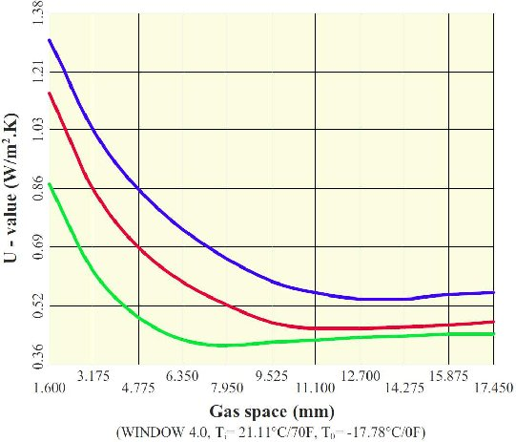
Figure 2. Optimum width for air, Argon and Krypton [4].
Window software was used to obtain numerical results [5]. The model uses the following equation to calculate the heat transfer coefficient U of the glazing [6]:
$\frac{1}{U}=\frac{1}{h_{e}}+\frac{1}{h_{t}}+\frac{1}{h_{i}}$ (1)
where h_{e}, h_{i} are heat transfer coefficients on the outside and inside of the structure; h_{t} represents total thermal transmittance of the glazing.
The inverse value of the total transmittance of the glazing program calculates:
$\frac{1}{h_{t}}=\sum_{1}^{N}{\frac{1}{h_{s}}}+\sum_{1}^{M}{d_{j}r_{j}}$ (2)
where N is number of cavities; d_{j} is thickness of each layer of the material; r_{j} represents specific heat resistance of each material (soda-lime glass specific heat resistance is 1.0 m.K/ W); M is number of layers.

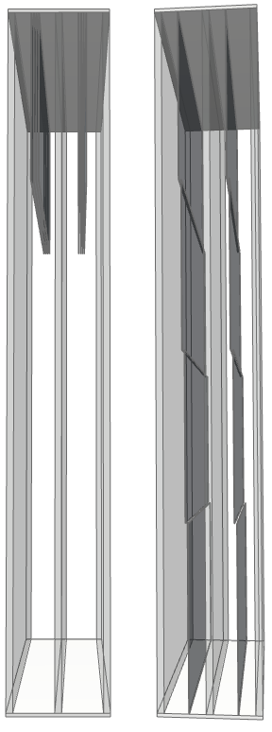 | Figure 3. Modes of operation of adaptive glazing concept. Mode 2 is shown on the left; mode 1 is displayed on the right side (see table 2).

The heat transfer of the individual cavities of the glass system is the sum of the radiation transmittance and the U value of the gas in the glass system:
$h_{s,k}=h_{r,k}+h_{g,k}$ (3)
where h_{s,k} is heat transfer through the cavity; h_{r,k} radiation transmittance; h_{g,} is U value of gas. The value of thermal transmittance caused by radiation can be calculated by:
$h_{t}={\left(\frac{1}{ε_{1,k}}+\frac{1}{ε_{2,k}}-1\right)}^{-1}T_{m}^{3}$ (4)
where σ is Stefan-Boltzmann constant; T_{m} is mean absolute temperature of the gas-filled cavity; ε_{1,k} and ε_{2,k} are modified emissivity of the surfaces enclosing the enclosed space between the panes glass at T_{m}. Model calculates thermal transmittance of gas according to standard EN 673 [5]:
$h_{g,k}=\frac{N_{u}λ_{k}}{S_{k}}$ (5)
where S_{k} is cavity width; λ_{k} is coefficient of thermal conductivity of gas; N_{u} is Nusselt number. The Nusselt number is based on the equation:
$N_{u}=A{\left(G_{r}P_{r}\right)}^{n}$ (6)
where A is constant; G_{r} is Grashof number; P_{r} represents Prandtl number; n is exponent. Grashof and Prandtl numbers are based on the equations:
$G_{r}=\frac{9,81s^{3}∆Tρ^{2}}{\left(T_{m}{ μ}^{2}\right)}$ (7)
$P_{r}=\frac{μ_{c}}{λ}$ (8)
where ΔT is the temperature difference between the glass surfaces enclosing the gas-filled cavity, ρ is density, μ represents dynamic viscosity, c is specific heat capacity, T_{m} is mean temperature.
- Results and discussion
Two modes of operation of the glass system were investigated by calculation using software WINDOW [4]. The heat transfer coefficient for Mode B experienced a deterioration of more than 0.334 (107%) compared to state A, table 3. Other thermal-optical parameters visible transmittance τ_{V} and solar factor g also recorded an increase, but this results from the removal (to a small extent) of the structure that limits heat and light transport.
Table 3. The resulting thermal-optical properties of the glass system in modes A and B.
Thermal-optical properties | A | B
τ_{V} [-] | 0.558 | 0.687
g [-] | 0.432 | 0.510
U_{g} [W/(m².K)] | 0.312 | 0.646
- Conclusion
The adaptability of the glass system is particularly important in relation to energy requirements and thermal comfort. Existing adaptive glass systems offer the possibility of changing properties, but at the expense of reducing visual contact with the exterior. The designed glass system capable of adaptation by configuration change offers two modes of operation. One mode with high thermal insulation capability that is able to handle harsh weather and the other mode that can create the conditions for the desired heat gains in winter and heat losses in summer. The properties of both glass system configurations were obtained by numerical analysis. The possibility of verifying the behaviour of the structure under real conditions by means of dynamic simulation is not possible, as the software setting does not assume that the structure under consideration will change over time. It is plan to provide experimental measurements of the glass system properties in a climate chamber to verify and evaluate measured and calculated data.
- References
[1] Mardaljevic J Waskett R K and Painter B 2016 Neutral daylight illumination with variable transmission glass: Theory and validation, Lighting Res. Technology 48 267–285
[2] Sadek A H and Mahrous R 2018 Adaptive Glazing Technologies: Balancing the Benefits of Outdoor Views in Healthcare Environments, Solar Energy 174 719-727
[3] Piccolo A and Simone F 2015 Performance Requirements for Electrochromic Smart Window, Journal of Building Engineering 3 94-103
[4] Vitro 2016 Gas Space Convection Effects on U-values in Insulating Glass Units
[5] Window 7.4.14 2017 NFRC Simulation manual, Lawrence Berkley laboratory
[6] EN 673 Glass in building. Determination of thermal transmittance (U value). Calculation method. (2011)

Acknowledgments
This research was supported by the Slovak Scientific Grant Agency (VEGA) in collaboration with Slovak Ministry of Education, Science, Research and Sports and Slovak Academy of Sciences (SAS), under Grant number 2/0017/20.

